Friday Quiz 15th May 2026
- Who is in Vienna tomorrow proclaiming their lack of technology to their family?
- The Prime Minister of which European country resigned this week?
- Complete the film quote with the name of the film: “If we could somehow harness this bolt of lightning, channel it into the flux capacitor, it just might work.
Next Saturday night, we're sending you _____ __ ___ ______”
- Who is this? 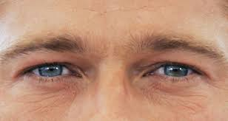
- Which country has the most cows, over 200 million?
- Which top flight European soccer club shares its name with a hero from Greek mythology?
- How many planets can be seen without a telescope (not counting Earth)?
- What did Peter the Great tax in order to encourage Russians to become more Western?
- What links the pictures?.  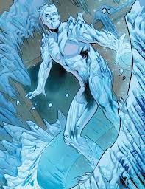 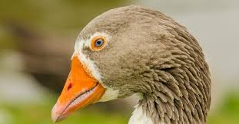

- Which UK city is this? 

- What ‘T’ is the classification of plants and animals into species, genus etc?
- Name the discontinued chocolate bar 
- What disease first emerged in 2002, with the largest outbreak happening in Hong Kong?
- Which artist walked a pet giant anteater around Paris on a lead as a publicity stunt?
- What 4-letter word is a fortified tower within a castle?
- Change the first letter of a Eurovision winner to find a teatime treat . Give both words.
- Name the film 
- Monique writes down a list of five numbers. The mean (average) of her first three numbers is −3. The mean of her first four numbers is 4. The mean of her first five numbers is −5. What is the difference between her fourth number and her fifth number

- What links the pictures?
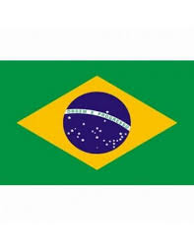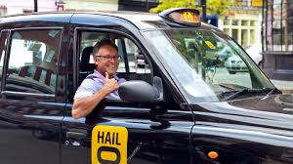
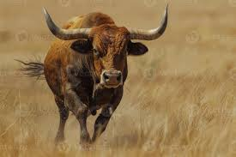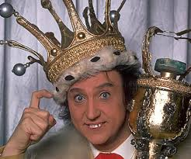

- Unscramble the two words: A A E H I I N N O O P R X Z

